Phonebook Record

Due date : Friday, 14/01/2022 Assigned by: Mr. Nataji Nirmal

Submitted by Mr. Ranganadh Narayanam, Batch: Ds20 Submitted on: 12/01/2022

STEP 1: INCLUDING RESULT

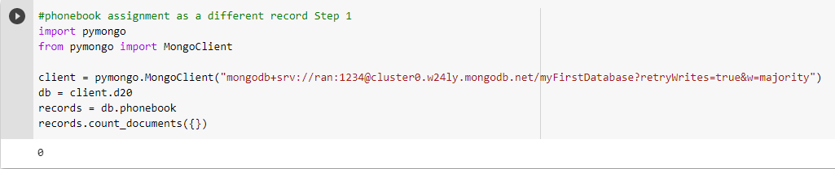

STEP 2:

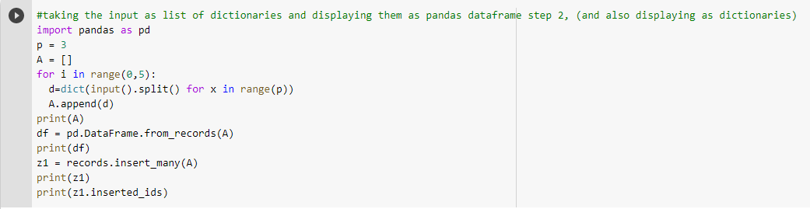

STEP 2: RESULT

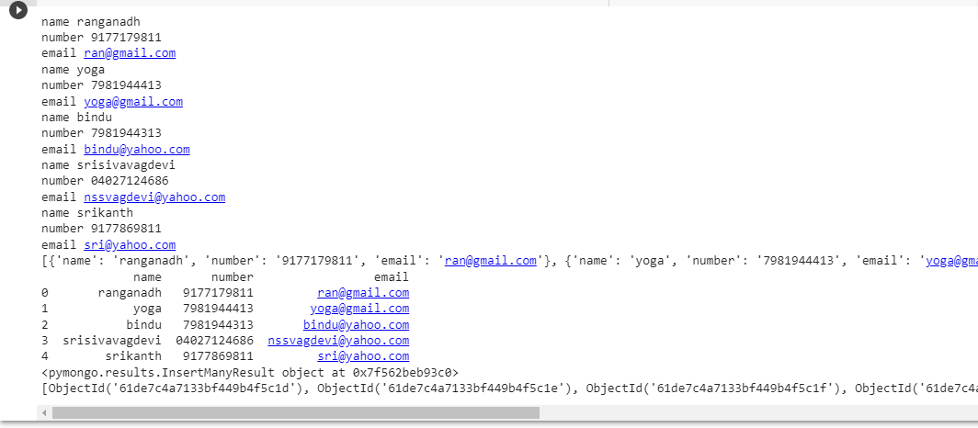

STEP 3: INCLUDING RESULT

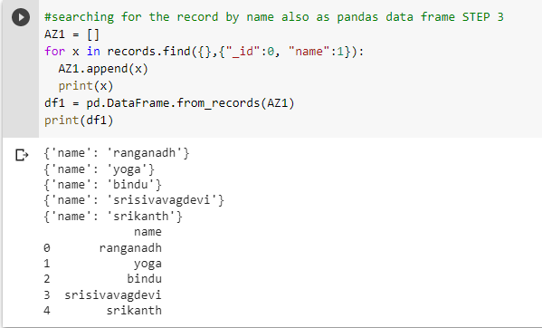

STEP 4: INCLUDING RESULT

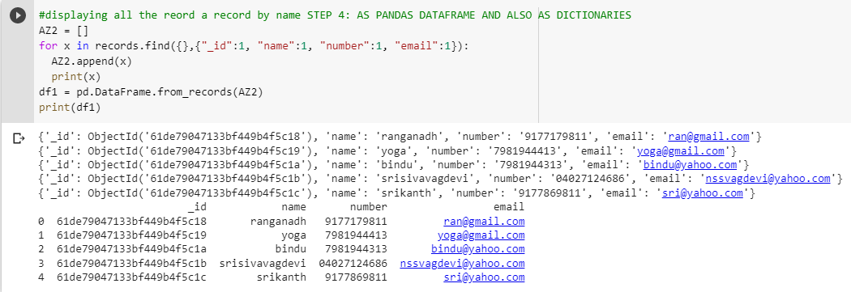

STEP 5 AND 6: INCLUDING RESULT

